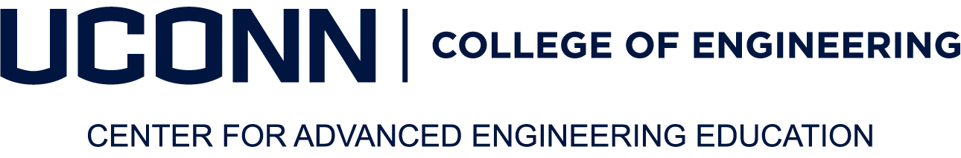
MENG in London Scholarship Request Form
The UConn College of Engineering Center for Advanced Engineering Education prides itself on its competitive pricing and the value of the education provided to our students. We are proud to offer 10% off all MENG fees to students who have been accepted into the MENG in London program, studying abroad in London, and who are unemployed or not receiving company sponsored financial assistance. The benefit cannot be combined with any other discount, veteran’s waiver or alumni financial assistance.

Please complete the form below to request scholarship assistance. All forms must be received at least 2 weeks prior to the start of the semester.

Biographical Information | U.S. Citizen: Yes ☐ No ☐
Gender: Male ☐ Female ☐ | Birth Date:
Last Name: | Current Employer:
Home Address: | First Name: | Middle Initial:
Email: | Daytime Phone:
 | Cell Phone:

Student Signature
By signing this form, the student acknowledges that they are a self-pay student and are either 1) unemployed, 2) not receiving reimbursement from an employer and/or 3) are not part of a veteran’s waiver program, and/or 4) are not receiving alumni financial assistance.

Eligibility for this scholarship is contingent on the student maintaining academic standards and status as a Master of Engineering student studying abroad in London. Additional credits taken outside of the 30-credit requirement or credits taken while the student is not studying abroad will not be eligible for this scholarship.

Signature of the Student______________________________________ DATE_________________

EMAIL COMPLETED FORM TO engrcaee@uconn.edu

For Office Use Only:
Degree Confirmed: ___________________ Grant Advice Processed: ___________________
Note:

