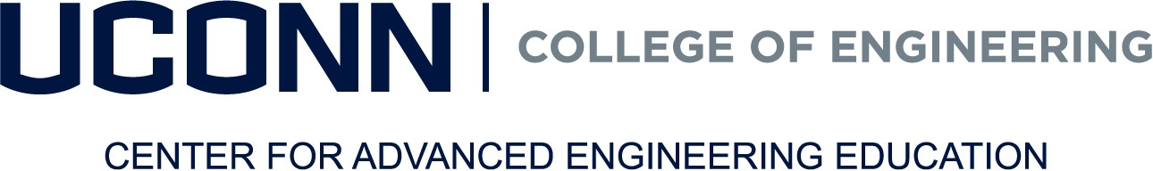

UConn Alumni Assistance Request
The UConn College of Engineering Center for Advanced Engineering Education prides itself on its competitive pricing and the value of the education provided to our students. We are proud to offer UConn Engineering alumni who are unemployed or not company sponsored an exclusive assistance of 10% off all program fees. This cannot be combined with any other assistance program or company sponsored tuition reimbursement plan including a veteran’s waiver.

Please complete the form below to request the assistance.

Biographical Information | U.S. Citizen: Yes ☐ No ☐
Student Admin #: | Birth Date:
Gender: Male ☐ Female ☐ | Current Employer:
Last Name: | First Name: | Middle Initial:
Home Address: | Daytime Phone:
 | Cell Phone:
Email:

Yr Degree Awarded | Field of Study

Student Signature
By signing this form, the student acknowledges that they are a self-pay student and are either 1) unemployed, 2) not receiving reimbursement from an employer and/or 3) are not part of a veteran’s waiver program.

Signature of the Student DATE

EMAIL COMPLETED FORM TO engrcaee@uconn.edu
Note:
Grant Advice Processed:
For Office Use Only:

Degree Confirmed:

